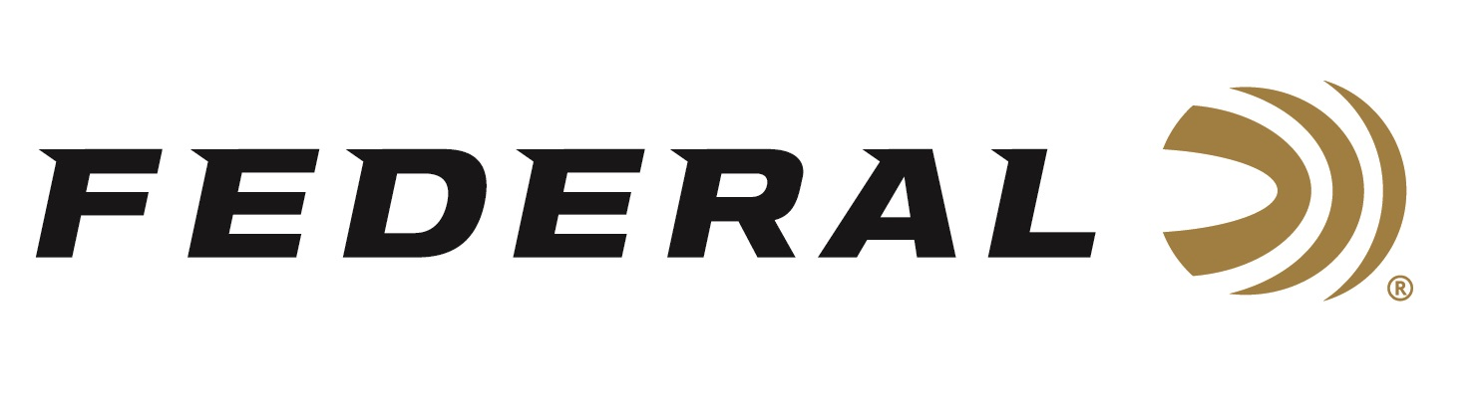

FOR IMMEDIATE RELEASE

Primed Nutrition Sponsors the “Tactical Games”

ANOKA, Minnesota – March 10, 2022 – The Tactical Games provide a platform to test the skills and readiness of tactical athletes from all backgrounds. Whether you are military, law enforcement, a competitive shooter, or a civilian gun enthusiast you can compete in The Tactical Games. Primed Nutrition is honored to partner with this series of ten events across the United States as a “Silver Sponsor” in 2022.

“We are excited to partner with The Tactical Games as a Silver-level sponsor for 2022,” states Jason Nash, VP of Marketing for Federal Ammunition and Primed Nutrition. “Our products are designed to help hunters and shooters optimize their performance in the field and on the range with a series of electrolytes, supplements, and bars. This partnership gives us exposure to some of the best tactical athletes in the world – athletes who are serious about their performance and their nutrition.”

“The Tactical Games is extremely excited to welcome Primed Nutrition to our team. Proper nutrition and supplementation are incredibly important when it comes to being a well-rounded tactical athlete. We look forward to having the Field Fuel, Fuel + Focus, and Elevate products available at all our 2022 events,” states Nick Thayer, President of The Tactical Games.

The Tactical games provides a venue for all shooters and athletes to compete against the best in the world to find weaknesses and test gear in the most stressful environment a competition can offer. To learn more about events, you can check out www.thetacticalgames.com/events/.

Primed Nutrition was born from Federal Ammunition's unrelenting pursuit to improve the shooting experience and Go Condition's scientifically developed supplements to increase focus and performance on the battlefield. These products are designed exclusively for hunters and shooters for energy to outlast the day.

Learn more about Primed Nutrition products at www.primednutrition.com. Primed products can be found at dealers nationwide or purchased online direct from Federal: https://www.federalpremium.com/merchandise/primed/.

Press Release Contact: JJ Reich
Senior Manager – Press Relations
E-mail: VistaPressroom@VistaOutdoor.com

About Federal Ammunition
Federal, headquartered in Anoka, MN, is a brand of Vista Outdoor Inc., an outdoor sports and recreation company. From humble beginnings nestled among the lakes and woods of Minnesota, Federal Ammunition has evolved into one of the world's largest producers of sporting ammunition. Beginning in 1922, founding president, Charles L. Horn, paved the way for our success. Today, Federal carries on Horn's vision for quality products and service with the next generation of outdoorsmen and women. We maintain our position as experts in the science of ammunition production. Every day we manufacture products to enhance our customers' shooting experience while partnering with the conservation organizations that protect and support our outdoor heritage. We offer thousands of options in our Federal Premium and Federal® lines-it's what makes us the most complete ammunition company in the business and provides our customers with a choice no matter their pursuit.

